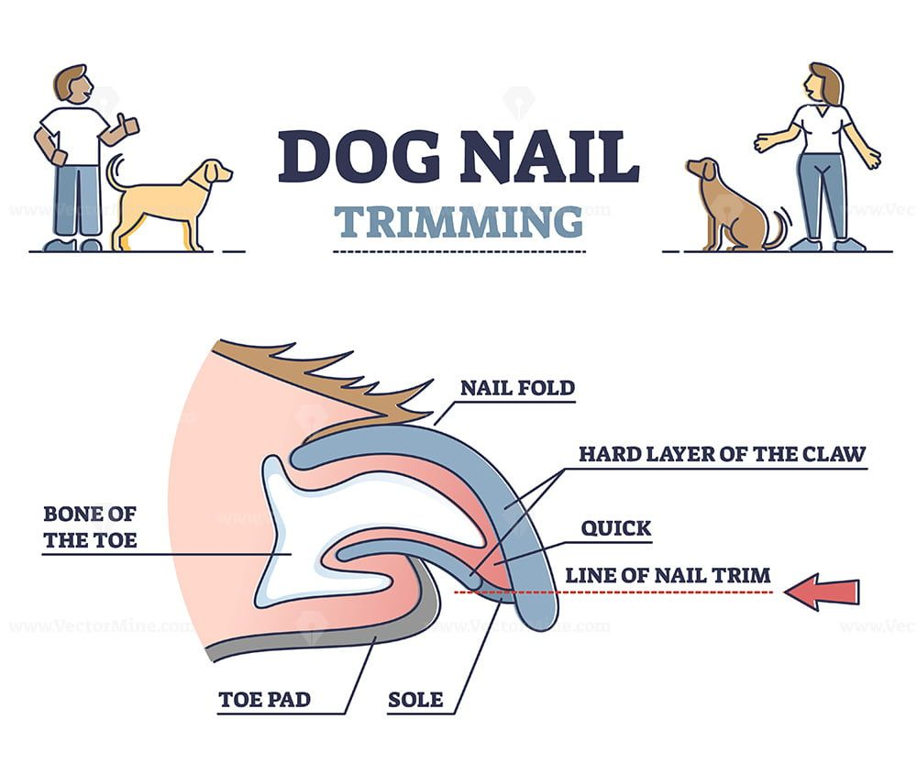
Doggie in the Window Nail Clipping Release Waiver
I understand that my dog is coming to Doggie in the Window LLC for a nail trimming. I also understand everything associated with that including:
  - The quick being cut accidentally, causing the dog to bleed temporarily.
  - My dog’s nails may not be cut as short as I would like if the quick is long, and I understand that regular nail trimming appointments will be made per my groomer’s advice.
  - I understand that the price may be a bit higher if my dog is difficult for the trimming.

Dog’s Name: ___________________________________________________________
Dog’s Breed:____________________________________________________________
Owner’s Name:_________________________________________________________
Owner’s Phone Number: ________________________________________________
Owner’s Signature: _____________________________________________________
Date: __________________________________________________________________

